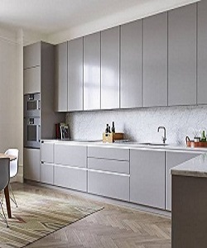

Kitchen Furniture

$326.79

Availability: In stock

Description

The material is a strong, stainless steel that produces a beautiful uniform appearance in kitchen, easy to clean. The smooth-surfaced doors are custom made to your kitchen project, available in the range of sheen levels.